FINAL MAJOR PROJECT

## Part 1: Project Proposal

Step 1: PCpoint.com web-app development final major project in ASP.NET

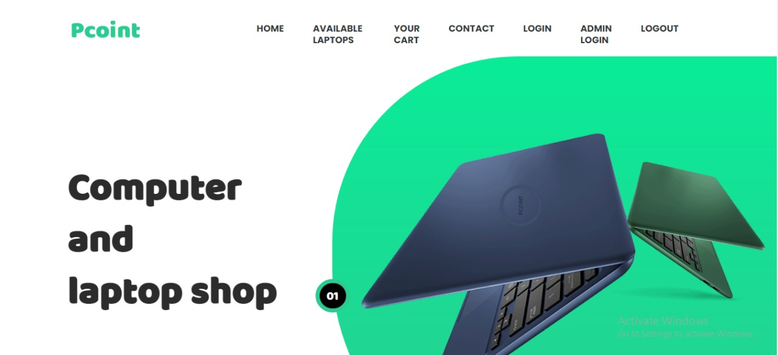

**Systems Analysis –** This platform was built with ASP.NET. The key feature is the ability to purchase computer and laptops. We focused the target system's requirements with a emphasis on user demands, which included learning about software product limits, learning about system-related issues or modifications, and addressing the project's influence on the organization and employees, among other things.

The project team assessed the project's scope and devised a timetable and resource allocation strategy based on their findings.

**Systems design** – This is a high-level description of how a computer-based system would satisfy the requirements; it is expected to be a single-user system that does not rely on data connection for the primary facility.

**Systems Specifications**

OS -Windows 10

IDE- Visual Studio

**Programming** – ASP.NET and C# was used for functionality completed as a working system in an MVC model.

Step 2***:*** Produced a project proposal contained that includes home page, order, check availability and User login etc.

Project Goal – Build a platform for users to buy and search laptops.

Project Objectives – The main objectives of the project was to enable users to buy laptops easily and provide an optimal user interface and user experience

Project Scope – A full-fledge website develop 5 page website development

1. Context – A laptop buying facility
2. ASP.NET language platform
3. Stakeholders of the product: People who want to buy laptops
4. Backend or API integration

Project Deliverables –

1. Analysis documentation
2. Design documentation
3. Executable program
4. User documentation

|  |  |  |
| --- | --- | --- |
| **Milestone** | **Time taken** | **Finalized** |
| Designing | 2 Days | Yes |
| Programming | 2 Days | Yes |
| Documentation | 2 days | Yes |

Resources

|  |  |
| --- | --- |
| Processor | 1 GHz |
| RAM | 512 MB |
| Disk space (minimum) |  |
| 32-bit | 4.5 GB |
| 64-bit | 4.5 GB |

ProjectMilestones

|  |  |  |
| --- | --- | --- |
| **Milestone** | **Time taken** | **Finalized** |
| Designing | 2 Days | Yes |
| Programming | 2 Days | Yes |
| Documentation | 2 days | Yes |

ProjectSchedule

1. The conclusion of the preliminary inquiry

2. Drafted design

3. Approval of the design

4. The prototype programme has been finished.

5. Signed-off stages of programme refinement

6. The programme has been completed.

7. The programme was put to the test

8. Completed system documentation

9. The user acceptance process has been finished.

10. Completion of the user report on system acceptability

Project Assumptions

1. Users are available during the project to provide information and software is available at the client site.

**Design**: 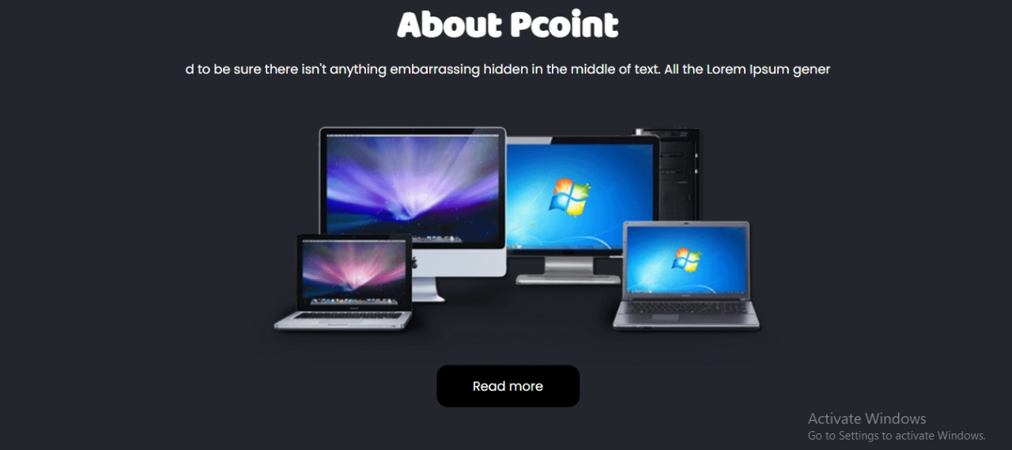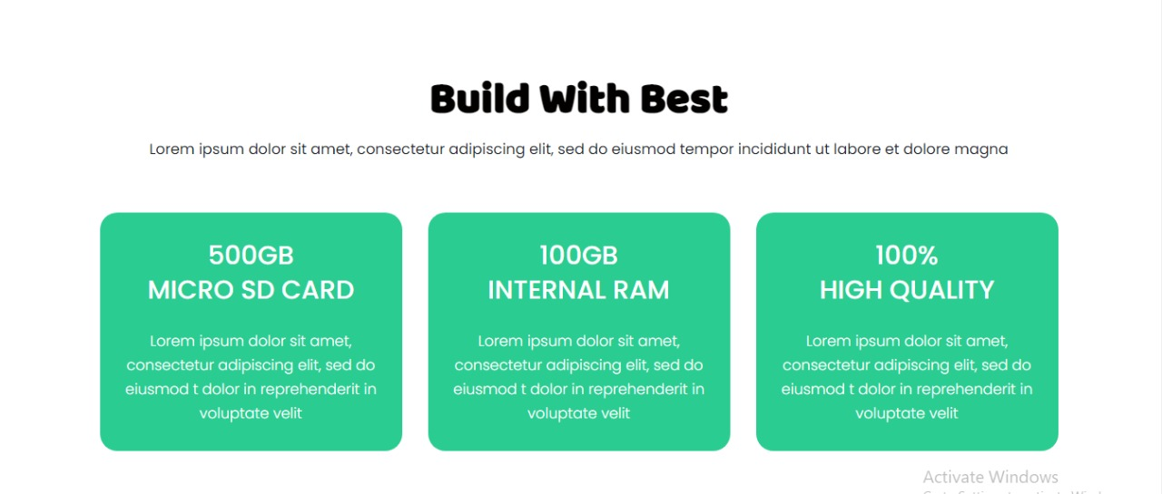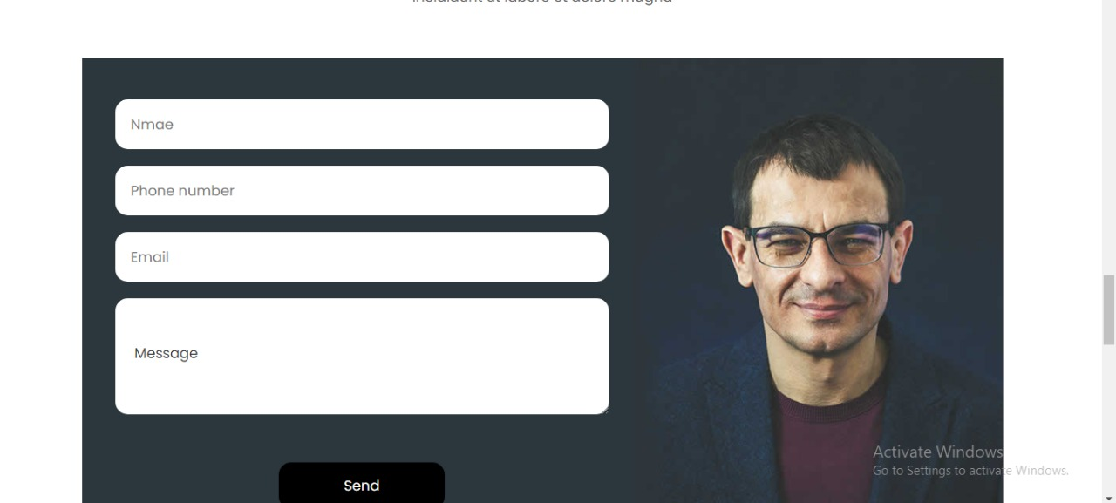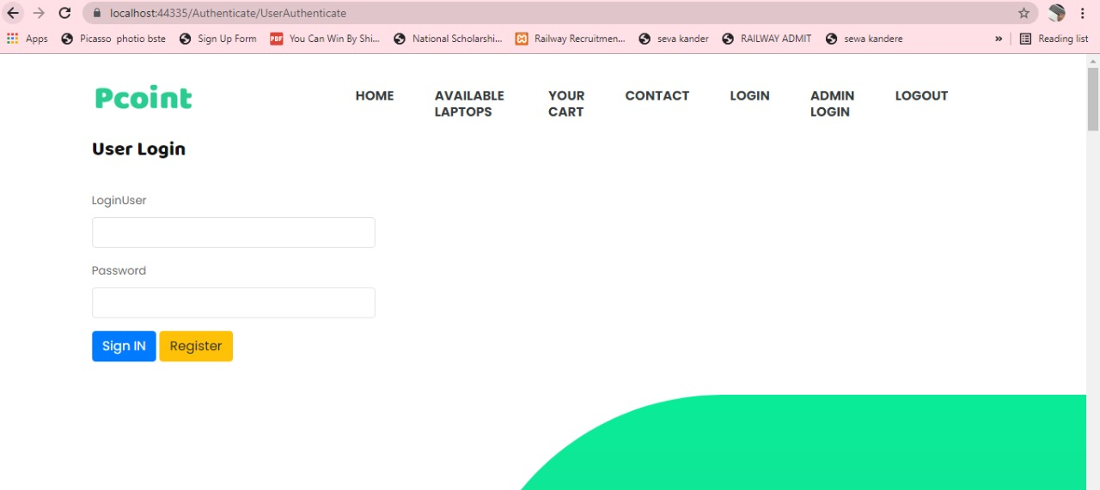

# **Part 2: Review your project**

Step 1: Final Product/Outcome - a platform to buy medicine